Chapter 01 Limits, Alternatives, and Choices

QUESTIONS

1. What is an opportunity cost? How does the idea relate to the definition of economics? Which of the following decisions would entail the greater opportunity cost: Allocating a square block in the heart of New York City for a surface parking lot or allocating a square block at the edge of a typical suburb for such a lot? Explain. LO1

Answer: An opportunity cost is what was sacrificed to do or acquire something else. The condition of scarcity creates opportunity cost. If there was no scarcity, there would be no need to sacrifice one thing to acquire another.

The opportunity cost would be much higher in New York City as the alternative uses for that square block are much more valuable than for a typical suburban city block.

2. Cite three examples of recent decisions that you made in which you, at least implicitly, weighed marginal cost and marginal benefit. LO1

Answer: Student answers will vary, but may include the decision to come to class, to skip breakfast to get a few extra minutes of sleep, to attend college, or to make a purchase. Marginal benefits of attending class may include the acquisition of knowledge, participation in discussion, and better preparation for an upcoming examination. Marginal costs may include lost opportunities for sleep, meals, or studying for other classes. In evaluating the discussion of marginal benefits and marginal costs, be careful to watch for sunk costs offered as a rationale for marginal decisions.

3. What is meant by the term “utility” and how does the idea relate to purposeful behavior? LO1

Answer: “Utility” refers to the pleasure, happiness, or satisfaction gained from engaging in an activity (eating a meal, attending a ball game, etc.). It is an important component of purposeful behavior because people will allocate their scarce time, energy, and money in an attempt to gain the most utility possible.

4. What are the key elements of the scientific method and how does this method relate to economic principles and laws? LO2

Answer: The key elements include the gathering of data (observation), the formulation of possible explanations (hypothesis), testing the hypothesis, determining the validity of the hypothesis, and repeated testing of hypotheses that have appeared to be valid in prior tests.

The scientific method is the technique used by economists to determine economic laws or principles. These laws or principles are formulated to explain and/or predict behavior of individuals or institutions.

5. Indicate whether each of the following statements applies to microeconomics or macroeconomics:
LO3
a. The unemployment rate in the United States was 9.7 percent in March 2010.
b. A U.S. software firm discharged 15 workers last month and transferred the work to India.
c. An unexpected freeze in central Florida reduced the citrus crop and caused the price of oranges to rise.
d. U.S. output, adjusted for inflation, decreased by 2.4 percent in 2009.
e. Last week Wells Fargo Bank lowered its interest rate on business loans by one-half of 1 percentage point.
f. The consumer price index rose by 2.7 percent from December 2008 to December 2009.

Answer:

Macroeconomics: (a), (d), and (f)

Microeconomics: (b), (c), and (e)

6. State (a) a positive economic statement of your choice, and then (b) a normative economic statement relating to your first statement. LO3

Answer: Student answers will vary. Example: (a) The unemployment rate is 4.8 percent; (b) the unemployment rate is too high. In general we treat “what is” statements as positive, “what should be” as normative, but keep an eye out for statements like “at full employment an increase in the production of pizzas should come at the cost of less robots.” Some students may incorrectly identify the statement as normative because of the term “should.”

7. What are economic resources? What categories do economists use to classify them? Why are resources also called factors of production? Why are they called inputs? LO4

Answer: Economic resources are the natural, human, and manufactured inputs used to produce goods and services. Economic resources fall into four main categories: labor, land (natural resources), real capital (machines, factories, buildings, etc.,) and entrepreneurs. Economic resources are also called factors of production because they are used to produce goods and services. They are called inputs because they go in to a production process (like ingredients go into a bowl to make a cake), with the resulting goods and services also being referred to as output.
8. Why is money not considered to be a capital resource in economics? Why is entrepreneurial ability considered a category of economic resource, distinct from labor? What are the major functions of the entrepreneur? LO4

Answer: Money is not considered a capital resource because money is not productive – it provides access to resources but itself does not directly contribute to the production of goods and services. Additionally, the quantity of money in circulation does not determine an economy’s productive capacity, while the amount of capital and other resources does. Doubling the amount of money in circulation does not change the economy’s physical capacity to produce goods and services. Money is, however, referred as a financial resource and financial capital, reflecting its ability to acquire real economic resources.

Entrepreneurial ability and labor are both human resources, but they perform different functions in the productive process. Entrepreneurial ability does not directly produce goods and services; it organizes the resources that do. Labor refers to the human inputs that directly engage in production.

Entrepreneurs are risk-takers: They coordinate the activities of the other three inputs for profit—or loss, which is why they are called risk-takers. Entrepreneurs sometimes manage companies that they own, but a manager who is not an owner is not necessarily an entrepreneur but may be performing some of the entrepreneurial functions for the company. Entrepreneurs are also innovators, or perhaps inventors, and profits help to motivate such activities.

9. Specify and explain the typical shapes of marginal-benefit and marginal-cost curves. How are these curves used to determine the optimal allocation of resources to a particular product? If current output is such that marginal cost exceeds marginal benefit, should more or fewer resources be allocated to this product? Explain. LO5

Answer: The marginal benefit curve is downward sloping, MB falls as more of a product is consumed because additional units of a good yield less satisfaction than previous units. The marginal cost curve is upward sloping, MC increases as more of a product is produced since additional units require the use of increasingly unsuitable resource. The optimal amount of a particular product occurs where MB equals MC. If MC exceeds MB, fewer resources should be allocated to this use. The resources are more valuable in some alternative use (as reflected in the higher MC) than in this use (as reflected in the lower MB).

10. Explain how (if at all) each of the following events affects the location of a country’s production possibilities curve: LO5
a. The quality of education increases.
b. The number of unemployed workers increases.
c. A new technique improves the efficiency of extracting copper from ore.
d. A devastating earthquake destroys numerous production facilities.

Answer:

(a) Assuming better education translates into better work skills, then productivity should rise and this would shift the curve outward.

(b) Should not affect location of curve. Production moves inward, away from the curve.

(c) The curve should shift outward as more production is possible with existing resources.

(d) The curve should shift inward with the destruction of resources (capital).

11. Suppose that, on the basis of a nation’s production possibilities curve, an economy must sacrifice 10,000 pizzas domestically to get the 1 additional industrial robot it desires but that it can get the robot from another country in exchange for 9000 pizzas. Relate this information to the following statement:
“Through international specialization and trade, a nation can reduce its opportunity cost of obtaining goods and thus ‘move outside its production possibilities curve.’” LO6

Answer: The message of the production possibilities curve is that an individual nation is limited to the combinations of output indicated by its production possibilities curve. International specialization means directing domestic resources to output which a nation is highly efficient at producing. International trade involves the exchange of these goods for goods produced abroad. Specialization and trade have the same effect as having more and better resources or discovering improved production techniques. The output gains from greater international specialization and trade are the equivalent of economic growth.

12. LAST WORD Studies indicate that married men on average earn more income than unmarried men of the same age and education level. Why must we be cautious in concluding that marriage is the cause and higher income is the effect?

Answer: Correlation does not necessarily mean that there is causation. The relationship could be purely coincidental or dependent on some other factor not included in the analysis. It is also possible that higher income is the variable that “causes” marriage.

PROBLEMS

1. Potatoes cost Janice $1 per pound, and she has $5.00 that she could possibly spend on potatoes or other items. If she feels that the first pound of potatoes is worth $1.50, the second pound is worth $1.14, the third pound is worth $1.05, and all subsequent pounds are worth $0.30, how many pounds of potatoes will she purchase? What if she only had $2 to spend? LO1

Answer: 3,2

Feedback: Janice will purchase potatoes until the value of potatoes is less than the cost of potatoes or until her income has been exhausted. For example, assume Janice has $5.00 to spend on potatoes or other items and the cost of a pound of potatoes is $1. Now assume the first pound of potatoes is worth $1.50 to Janice. She will purchase this pound of potatoes since the value of the pound of potatoes ($1.50) is greater than the cost ($1). If the second pound is worth $1.14 and the third pound is worth a $1.05 then Janice will purchase these as well since the value exceeds the cost of $1. If all remaining pounds are worth $0.30 then Janice will not purchase these because the value is less than the cost. So, Janice will purchase 3 pounds of potatoes at total cost of $3.00.

Now assume Janice only has $2.00 to spend on potatoes. She will purchase the first pound because it is worth $1.50 to her and it only costs a $1. She will purchase the second pound because it is worth $1.14. She has now spent her entire income on potatoes. She would like to purchase the third pound because the value of this pound of potatoes is $1.05, but she does not have the income to make this purchase. So, Janice will purchase 2 pounds of potatoes at a total cost of $2.00.

2. Pham can work as many or as few hours as she wants at the college bookstore for $9 per hour. But due to her hectic schedule, she has just 15 hours per week that she can spend working at either the bookstore or at other potential jobs. One potential job, at a café, will pay her $12 per hour for up to 6 hours per week. She has another job offer at a garage that will pay her $10 an hour for up to 5 hours per week. And she has a potential job at a daycare center that will pay her $8.50 per hour for as many hours as she can work. If her goal is to maximize the amount of money she can make each week, how many hours will she work at the bookstore? LO1

Answer: 4.

Feedback: Pham will choose to work at the bookstore as long as the wage rate at the bookstore exceeds her other opportunities. However, if another job offers a higher wage rate she will choose employment there. She will work until her total time allotment (for work) is exhausted.
For example, assume Pham only has 15 hours per week that she can work and the wage rate at the bookstore is $9 per hour. She can also spend her time working at a café that will pay her $12 per hour for up to 6 hours per week, at a garage that will pay her $10 an hour for up to 5 hours per week, and at a daycare center that will pay her $8.50 per hour for as many hours as she can work.
She will choose to work at the café for the full 6 hours because the wage rate at the café is $12 per hour, which is greater than the wage rate at the bookstore of $9. This leaves her with 9 hours of work time remaining. Next, she will choose to work at the garage for the full 5 hours because the wage rate here is $10, which again is greater than the bookstore wage rate $9. After this decision she only has 4 hours of work time remaining. She will choose to work these last 4 hours at the bookstore because the bookstore wage rate of $9 exceeds the daycare center wage rate of $8.50.

3. Suppose you won $15 on a lotto ticket at the local 7-Eleven and decided to spend all the winnings on candy bars and bags of peanuts. The price of candy bars is $.75 and the price of peanuts is $1.50. LO4
a. Construct a table showing the alternative combinations of the two products that are available.
b. Plot the data in your table as a budget line in a graph. What is the slope of the budget line? What is the opportunity cost of one more candy bar? Of one more bag of peanuts? Do these opportunity costs rise, fall, or remain constant as each additional unit of the product is purchased?
c. Does the budget line tell you which of the available combinations of candy bars and bags of peanuts to buy?
d. Suppose that you had won $30 on your ticket, not $15. Show the $30 budget line in your diagram. Has the number of available combinations increased or decreased?

Answers:

Part a:

Consumption alternatives
Goods | A | B | C | D | E | F
Candy bars | 0 | 4 | 8 | 12 | 16 | 20
Bags of peanuts | 10 | 8 | 6 | 4 | 2 | 0

Part b:

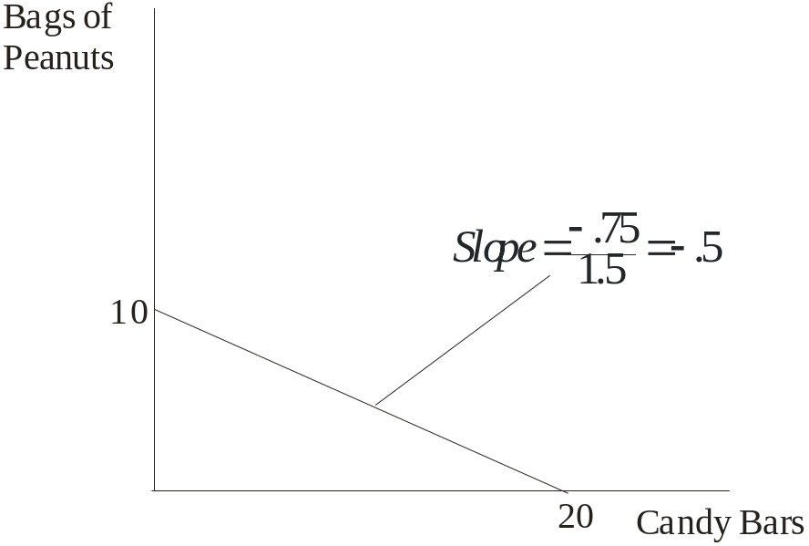

Feedback: The slope for the budget line above, with candy bars on the horizontal axis, is -0.5 (= -P_{cb}/P_{bp}). Note that the figure could also be drawn with bags of peanuts on the horizontal axis. The slope of that budget line would be -2.

The opportunity cost of one more candy bar is ½ of a bag of peanuts. The opportunity cost of one more bag of peanuts is 2 candy bars. These opportunity costs are constant. They can be found by comparing any two of the consumption alternatives for the two goods.

Part c: No; it only tells you what is possible.

Feedback: The budget line does not tell you which of the available combinations of candy bars and bags of peanuts to buy. You will need to use your preference relationship for candy bars and bags of peanuts to determine which combination to buy. The budget line only tells you which combinations are feasible.
Part d: Increased.

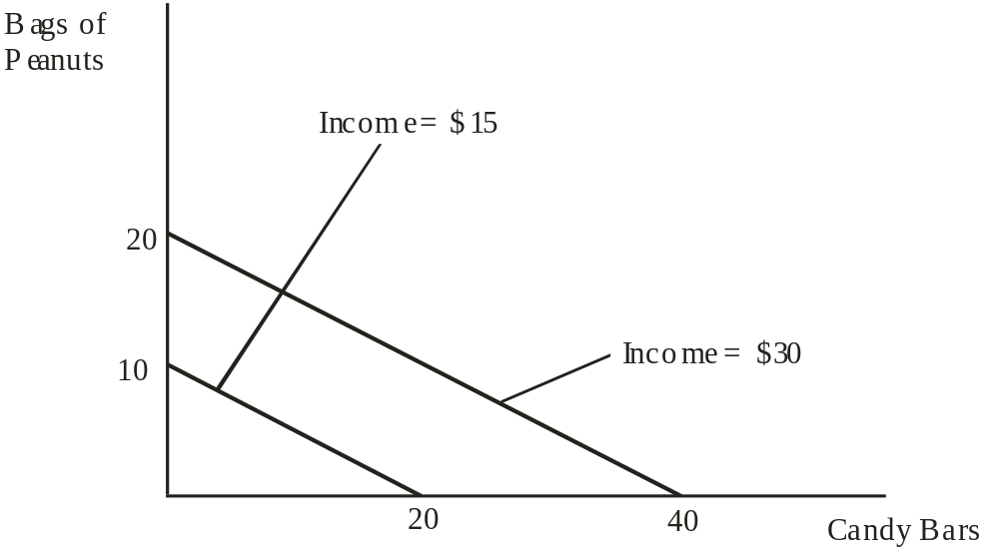

Feedback: The budget line at $30 would be preferable because it would allow greater consumption of both goods.

4. Suppose that you are on a desert island and possess exactly 20 coconuts. Your neighbor, Friday, is a fisherman, and he is willing to trade 2 fish for every 1 coconut that you are willing to give him. Another neighbor, Kwame, is also a fisherman, and he is willing to trade 3 fish for every 1 coconut. LO4
a. On a single figure, draw budget lines for trading with Friday and for trading with Kwame. (Put coconuts on the vertical axis.)
b. What is the slope of the budget line from trading with Friday?
c. What is the slope of the budget line from trading with Kwame?
d. Which budget line features a larger set of attainable combinations of coconuts and fish?
e. If you are going to trade coconuts for fish, would you rather trade with Friday or Kwame?

Answers:

Part a: < Connect editor, make sure that both lines can be placed on a single figure and that coconuts are on the vertical axis >
Coconuts
Fish
20
40
60
Trade with Friday
Slope = -1/2
Trade with Kwame
Slope = -1/3

Part b: -1/2

Feedback: The slope of the budget line from trading with Friday equals -(1/2). This implies that for every coconut I give up, Friday must give up two fish. Or, for every fish that Friday gives up, I must give up (1/2) a coconut.

Part c: -1/3

Feedback: The slope of the budget line from trading with Kwame equals -(1/3). This implies that for every coconut I give up, Kwame must give up three fish. Or, for every fish that Friday gives up, I must give up (1/3) a coconut.

Part d: The budget line from trading with Kwame

Feedback: The budget line from trading with Kwame features a larger set of attainable combinations of coconuts and fish. Because Kwame is willing to give up more fish per coconut, I can consume more of both (assuming I make a trade). This implies that you would prefer to trade with Kwame.

Part e: Kwame

Feedback: Because Kwame is willing to give up more fish per coconut, I can consume more of both (assuming I make a trade). This implies that you would prefer to trade with Kwame.

5. Below is a production possibilities table for consumer goods (automobiles) and capital goods (forklifts):
LO5
a. Show these data graphically. Upon what specific assumptions is this production possibilities curve based?
b. If the economy is at point C, what is the cost of one more automobile? Of one more forklift?
Which characteristic of the production possibilities curve reflects the law of increasing opportunity costs: its shape or its length?
c. If the economy characterized by this production possibilities table and curve were producing 3 automobiles and 20 fork lifts, what could you conclude about its use of its available resources?
d. Is production at a point outside the production possibilities curve currently possible? Could a future advance in technology allow production beyond the current production possibilities curve? Could international trade allow a country to consume beyond its current production possibilities curve?

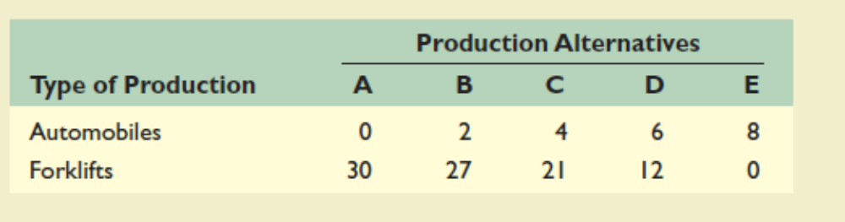

Answers:

Part a: (See figure below.) The assumptions are full employment, fixed supplies of resources, fixed technology and two goods.
automobiles
forklifts
8
30
D (12,6)
C (21,4)
B (27,2)
Part b: 4 automobiles and 21 forklifts; its shape.

Feedback: Consider the following example:

Assume the economy is producing at point C. Thus, the economy is producing 4 automobiles and 21 forklifts.

The cost of producing one more automobile can be found by moving to point D and calculating the number of forklifts given up for the 2 additional automobiles. At point D the economy is producing 12 forklifts, which is a loss of 9 forklifts (moving from C to D) for the 2 additional automobiles. Thus the cost of 1 more automobile equals 9 (forklifts) divided by 2 (automobiles), or (9/2) = 4.5 forklifts.

The cost of producing one more forklift can be found in an equivalent fashion. First, we will move to point B (from point C). Here we must give up 2 automobiles to get 6 forklifts. Thus, the cost of 1 more forklift equals 2 (automobiles) divided by 6 (forklifts), which is (2/6) = (1/3).
In review, take the cost (loss) and divide by the gain. If we were at point D, the cost of one more forklift equals 2 automobiles (loss) divided by 9 forklifts (gain). Thus, the cost of 1 more forklift at point B is (2/9) automobiles.

Increasing opportunity cost implies that we must give up more of a particular good to get an additional unit of a different good. This implies as we move along the production possibilities curve (from left to right) I must give up more automobiles to get an additional forklift. Thus, the SHAPE of the schedule captures the increasing opportunity cost concept.

Part c: Underutilizing.

Feedback: The economy is underutilizing resources (inside the PPC).

Part d: No; Yes; Yes.

Feedback: No, the country cannot produce outside its PPC. Yes, a technological advance would shift the PPC outward allowing the country produce more with a given amount of inputs. Yes, by specializing in goods we have a comparative advantage producing we can trade to gain access to goods beyond our own PPC.

6. Look at Figure 1.3. Suppose that the cost of cheese falls, so that the marginal cost of producing pizza decreases. Will the MC curve shift up or down? Will the optimal amount of pizza increase or decrease?LO5

Answers: MC will shift down; the optimal amount of pizza will increase.

Feedback: To think about cost schedules we must think about input costs. If the cost of cheese falls, then the cost of making pizza is cheaper for all pizzas. This implies that the marginal cost schedule will shift down reflecting the lower input cost. For a given demand schedule, the optimal amount pizza produced and sold will increase and the equilibrium price would fall. The opposite story would apply if the cost of cheese were to increase.

7. Referring to the table in problem 5, suppose improvement occurs in the technology of producing forklifts but not in the technology of producing automobiles. Draw the new production possibilities curve. Now assume that a technological advance occurs in producing automobiles but not in producing forklifts. Draw the new production possibilities curve. Now draw a production possibilities curve that reflects technological improvement in the production of both goods. LO6

Answers: See figures.

Technological advance in producing forklifts and not automobiles.

Feedback: This implies we can produce more forklifts with the given resources, so the schedule will shift out along the horizontal axis.

automobiles
forklifts
8
30
Technological advance in producing automobiles and not forklifts.

Feedback: This implies we can produce more automobiles with the given resources, so the schedule will shift up along the vertical axis.
automobiles
forklifts
8
30

Technological in advance in producing automobiles and forklifts.

Feedback: This implies we can produce more forklifts and automobiles with the given resources, so the schedule will shift up out along the vertical and horizontal axes.

automobiles
forklifts
8
30

8. On average, households in China save 40 percent of their annual income each year, whereas households in the United States save less than 5 percent. Production possibilities are growing at roughly 9 percent annually in China and 3.5 percent in the United States. Use graphical analysis of “present goods” versus “future goods” to explain the differences in growth rates. LO6

Answers: See figures below

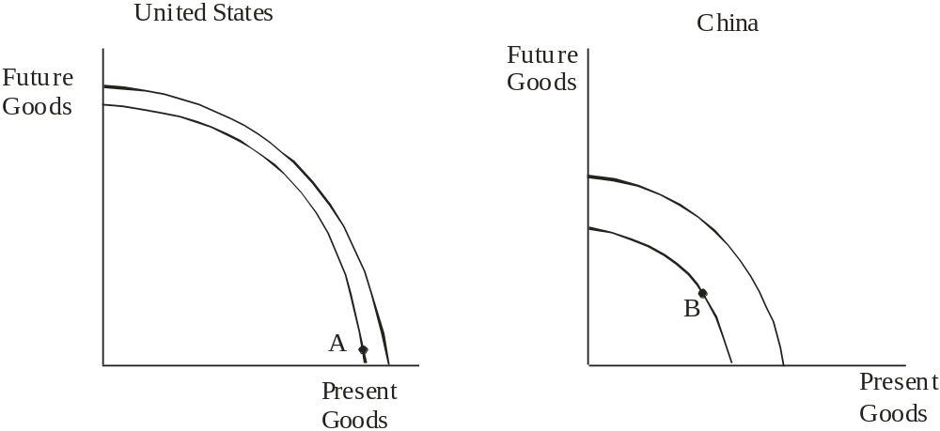

Feedback: Since the United States is consuming more today rather than saving, their production possibilities curve will shift out slower (less) over time because they are accumulating less capital. China's production possibilities curve will shift out faster (more) over time because they are accumulating more capital. See diagrams below.

